**Task-12 Screenshots**

**Question-01**

**Create a table Empl to store the below data’s**

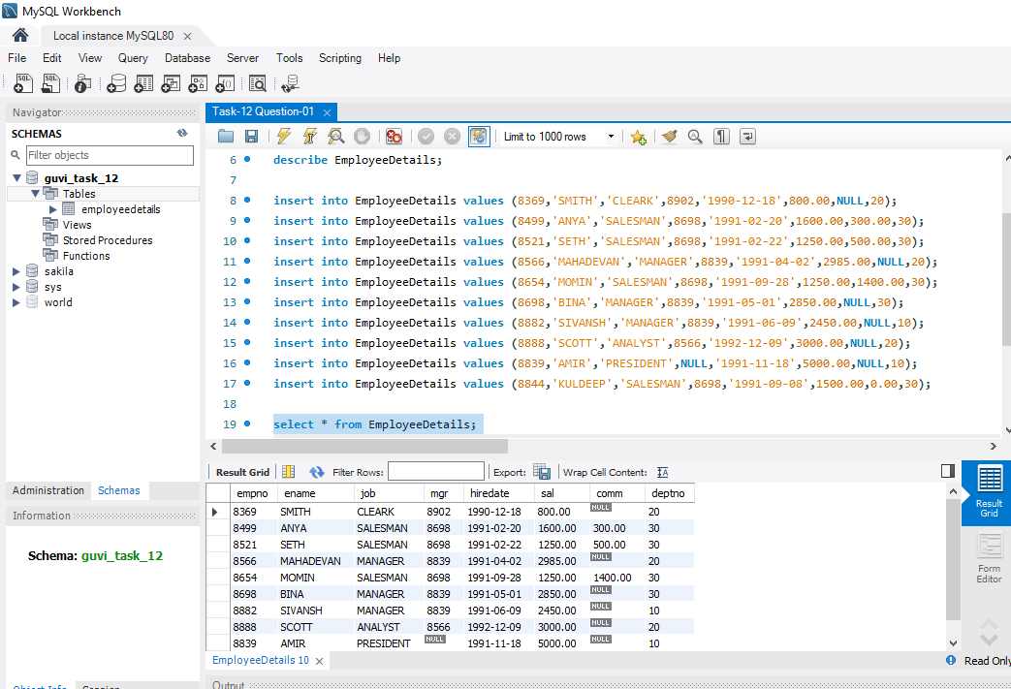

**A.Display Name and Salary of employees whose salary**

**greater than or equal to 2200.**

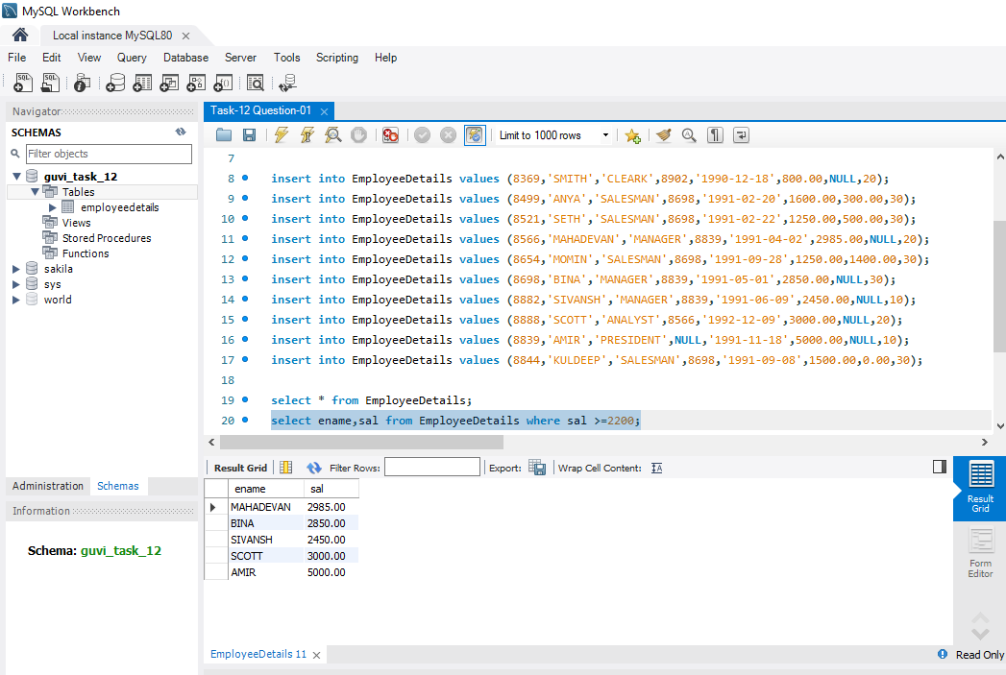

**B.Display details of employees who are not getting**

**commission**

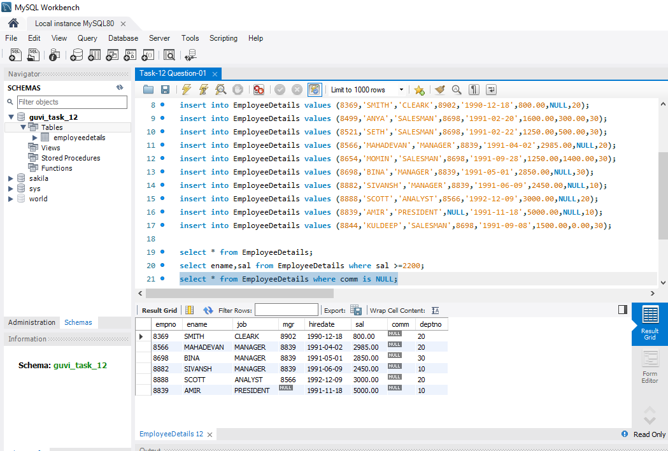

**C.Display names and sal of employees who don’t have salary**

**range between 2500 to 4000**

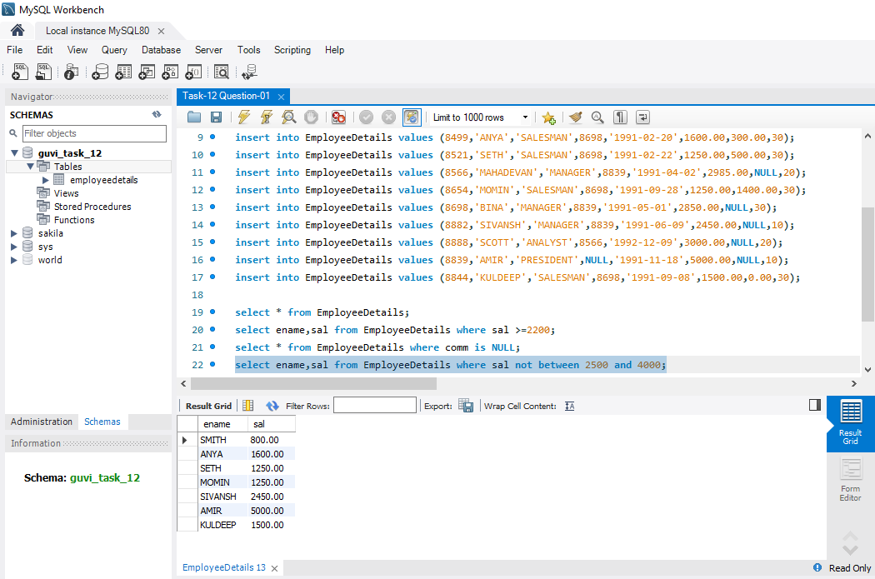

**D.Display names,job title and salary of employees,who don’t**

**have manager**

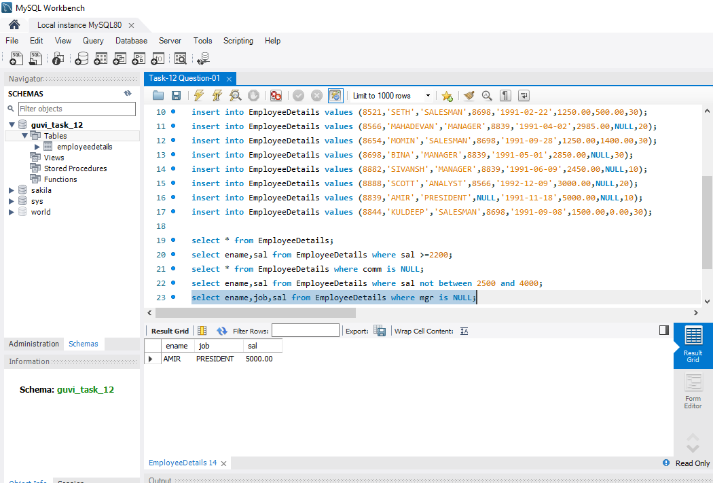

**E.Display names of an employees,whose name contains ‘A’**

**as third alphabet**

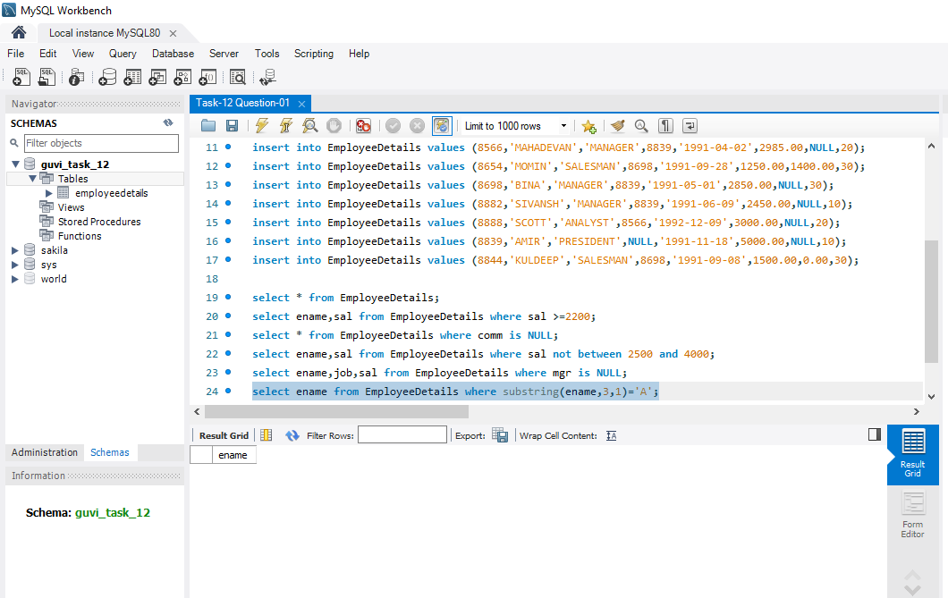

**F.Display names of an employees,whose name contains ‘T’**

**as the last alphabet**

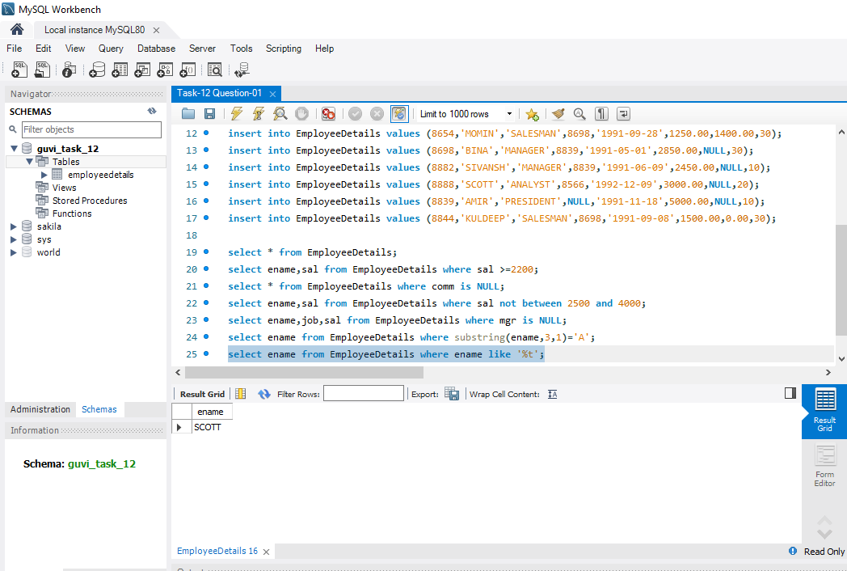

**Question-02**

**Program for JDBC connectivity and insert the data**

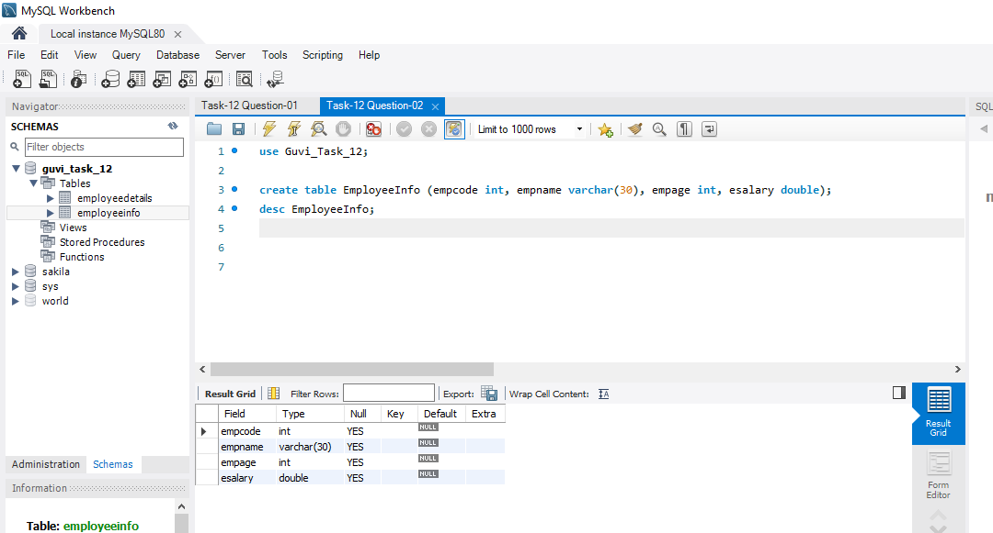

**Inserting data to SQL**

